

**Faculty of Business and Information Technology**

Bachelor of Information Technology

**IT5x82: Fundamentals of Data Models and Databases**

**21600681**

Contents

Executive summary 3

list of assumptions 4

CRUD Matrix diagram 5

entity relationship diagram 6

SQL CREATE TABLE commands 7

SQL INSERT 8

SQL SELECT query 9

consistency of the database system 10

# Executive summary

Thomas Cook Travels is a business that helps people plan their vacation. Thomas Cook Travels promotes resorts and matches customers with the resorts. Currently, Thomas Cook Travels performs its booking service on paper but it would like to automate these processes.

The purpose of this assignment is to document the requirements for a database system using models created in Visio and Visual Paradigm.

Can it be done?

Yes!!!

# list of assumptions

need one column for each category to record these details. {

Mountain, Seaside and Other

Breakfast, Dinner Only, All Meals, Kitchen and None

Singles, Couples, Family and Any

The Codes used for Preferred Locale (M, S and O) relate to Mountain, Seaside and Other, respectively.

The codes used for Preferred Lifestyle (S, C, F and A) relate to Singles, Couples, Family and Any.

The codes used for Preferred Meal Service (BRK, DIN, ALL and KIT) relate to Breakfast, Dinner Only, All Meals and Kitchen.

Each vacation may be associated with a number of excursions. The date and activity of each excursion is listed in the above form.

# CRUD Matrix diagram

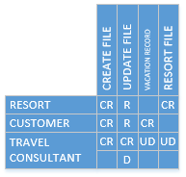

# Entity relationship diagram

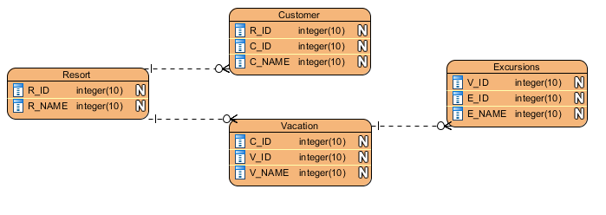

# SQL CREATE TABLE commands

CREATE DATABASE Thomas_Cook_Travels

USE Thomas_Cook_Travels

CREATE TABLE RESORT

(

R_ID VARCHAR(20) NOT NULL

, R_NAME VARCHAR(20) NOT NULL

);

CREATE TABLE CUSTOMER

(

R_ID VARCHAR(20) NULL

, C_ID VARCHAR(20) NOT NULL

, C_NAME VARCHAR(20) NOT NULL

);

CREATE TABLE VACATION

(

R_ID VARCHAR(20) NULL

, V_ID VARCHAR(20) NOT NULL

, V_NAME VARCHAR(20) NOT NULL

);

CREATE TABLE EXCURSIONS

(

V_ID VARCHAR(20) NULL

, E_ID VARCHAR(20) NOT NULL

, E_NAME VARCHAR(20) NOT NULL

);

USE Thomas_Cook_Travels

ALTER TABLE RESORT

ADD R_ID datatype

USE Thomas_Cook_Travels

ALTER TABLE RESORT

ADD PRIMARY KEY (R_ID)

,

ALTER TABLE CUSTOMER

ADD PRIMARY KEY (C_ID)

,

ALTER TABLE VACATION

ADD PRIMARY KEY (V_ID)

,

ALTER TABLE EXCURSIONS

ADD PRIMARY KEY (E_ID)

USE Thomas_Cook_Travels

ALTER TABLE CUSTOMER

ADD FOREIGN KEY (R_ID)

REFERENCES RESORT(R_ID)

,

ALTER TABLE VACATION

ADD FOREIGN KEY (R_ID)

REFERENCES RESORT(R_ID)

ALTER TABLE EXCURSIONS

ADD FOREIGN KEY (V_ID)

REFERENCES VACATION(V_ID)

SQL INSERT **commands used to populate each table with at least two records.**

INSERT INTO RESORT (R_ID, R_NAME)

VALUES ('1','Tom'),

('2','Jim');

INSERT INTO CUSTOMER (R_ID, C_ID, C_NAME)

VALUES

(‘1’, '1','Tom'),

(‘2’, '2','Jim')

INSERT INTO VACATION (R_ID, V_ID, V_NAME)

VALUES (‘1’, '123','Pool'),

(‘2’, '213','King');

INSERT INTO EXCURSIONS (V_ID, E_ID, E_NAME)

VALUES (‘123’, '1234','Hill'),

(‘213’, '2134','Lake');

SQL SELECT query **that extracts all the excursion records for each vacation booked by every client.**

**SELECT * FROM** EXCURSIONS;

Consistency of the database system **as compared with its design e.g. the table names, column names and the data types used.**

How well the Modelling tools in Visio have been used to document the system requirements e.g. the clarity of the models, models appropriately named, symbols used correctly etc.

Good

A list of Unresolved questions or problems that have come about from the analysis of the system’s requirements. If none were encountered, say so.

No budget